OPERATORS IN JAVASCRIPT

There are two types of operators are there in Java script. They are,

1. Arithmetic operators
2. Comparison operators

Arithmetic Operators:

The basic arithmetic operations such as (+, -, \*, /, %, \*\*) were performed in this operation.

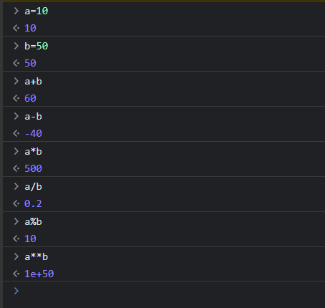

Comparison Operators:

Comparison operators are used to compare variables or values.

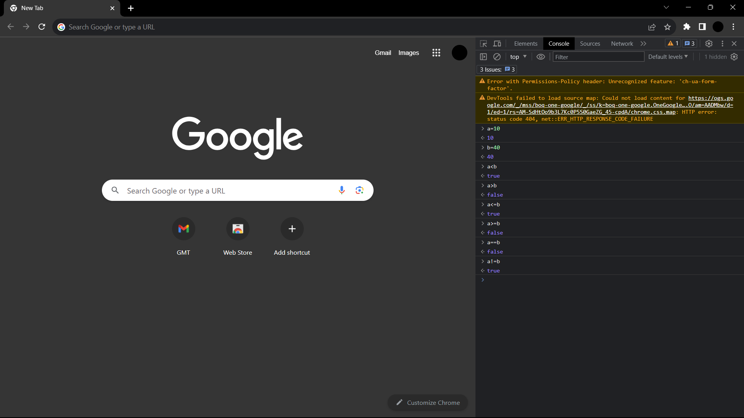

Difference Between == and ===

==

It is a normal equality operator. Where the type is not important where the values are same.

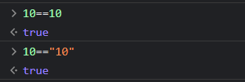

===

It is a strict equality where the type and value must same.

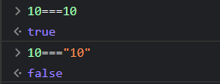

Here the === is recommended, because it is more specific and more safe.

NaN:

It is a data type.

It means Not a Number.

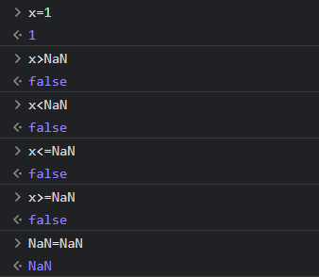

NaN!=NaN is the only way to get the output as true.

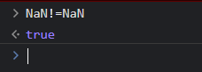

Conditional Statements:

1. If
2. If else
3. Else if

